With the help of a suitable graph, explain the concept of Big-Oh (O) notation and illustrate how it represents the upper bound of an algorithm's growth rate.

With the help of a suitable graph, explain the concept of Theta notation and illustrate how it represents the upper bound of an algorithm's growth rate.

Differentiate between best-case, average-case, and worst-case analysis

With the help of a suitable graph, explain the concept of omegha notation and illustrate how it represents the upper bound of an algorithm's growth rate.

Use Masters theorem to find the complexity of the following recurrence relation: T(n) = 9T(n/3) + n

Determine the solution to the recurrence relation T(n) = 2T(n/2) + n using the recursion tree method.

Use the Master Theorem to find the complexity of the following recurrence relation: T(n) = 4T(n/2) + n

Determine the growth rate of the function: f(n) = 3n² + 5n + 7.

Solve the following recurrence relation using back substitution method:

T(n)= T(n-1)+n with base case, T(1)=0

Write an algorithm for selection sort?

WWrite an algorithm for insertion sort?

Write an algorithm for Bubble sort?
An online bookstore stores the following book IDs in an unsorted array:
38, 12, 45, 7, 23, 19, 4, 31
Apply the Merge Sort algorithm to arrange the IDs in ascending order.
a) Show the division of the array into sub-arrays. (1 mark)
b) Show the merging steps until the final sorted array is obtained. (2 marks)
c) State the time complexity of Merge Sort. (1 mark)

Q2b. Binary Search — 3 Marks
Q2b. A sorted array contains the following employee IDs:
12, 25, 31, 46, 58, 64, 72, 85, 91
Apply Binary Search to find the employee ID 64.Show the values of low, high, mid, and the comparison made at each step. State the time complexity of Binary Search.
Expected Answer:
Step | Low | High | Mid | A[Mid] | Comparison
1 | 0 | 8 | 4 | 58 | 64 > 58 → search right
2 | 5 | 8 | 6 | 72 | 64 < 72 → search left
3 | 5 | 5 | 5 | 64 | Found
Therefore, 64 is found at index 5 (or position 6).

A set of product prices is stored as follows:
45, 12, 78, 34, 23, 56, 10
Apply the Quick Sort algorithm to arrange the elements in ascending order. Use the first element as the pivot at each partition step.Show the partitioning after each pivot selection. .State the worst-case time complexity of Quick Sort.
A temperature monitoring system records the following temperatures during a day:
38, 25, 42, 19, 31, 45, 28, 36
Apply the divide-and-conquer method for finding the minimum and maximum values.

A relief organization has a truck with a maximum carrying capacity of 50 kg. The following relief materials are available:
Material | Weight (kg) | Value (₹)
A | 10 | 60
B | 20 | 100
C | 30 | 120
D | 15 | 90
Apply the Fractional Knapsack greedy algorithm to determine the maximum value that can be carried in the truck.Select the materials one by one using the greedy strategy. Show the weight and value added at each step.

A relief organization has a helicopter with a maximum carrying capacity of 70 kg. The following relief materials are available: Material Weight (kg) Value (₹) X 40 200 Y 25 150 Z 20 100 W 10 60 Apply the Fractional Knapsack greedy algorithm to determine the maximum value that can be carried in the helicopter. Select the materials one by one using the greedy strategy. Show the weight and value added at each step.

A university wants to determine the shortest communication routes between its departments. The weighted graph below represents the communication cost between departments.
Apply Dijkstra's algorithm to find the shortest paths from source vertex A to all other vertices. Determine the shortest path from A to F and its total cost.
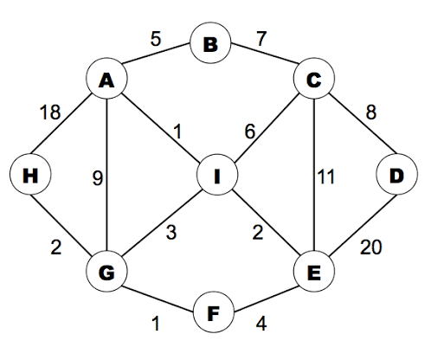

Apply Dijkstra's algorithm to find the shortest paths

